CpE 111 Homework Assignment #8 Maximum – 100pts

HW#8 is due at the beginning of class on Apr 24, 2006. You must always show or explain your work in a neat and orderly format. You are encouraged to discuss ideas with other students and consult references but your work must be your own.

1. The Set and Reset signals shown below are applied to an SR latch. Draw the output waveform Q(t). (Ignore all timing delays)

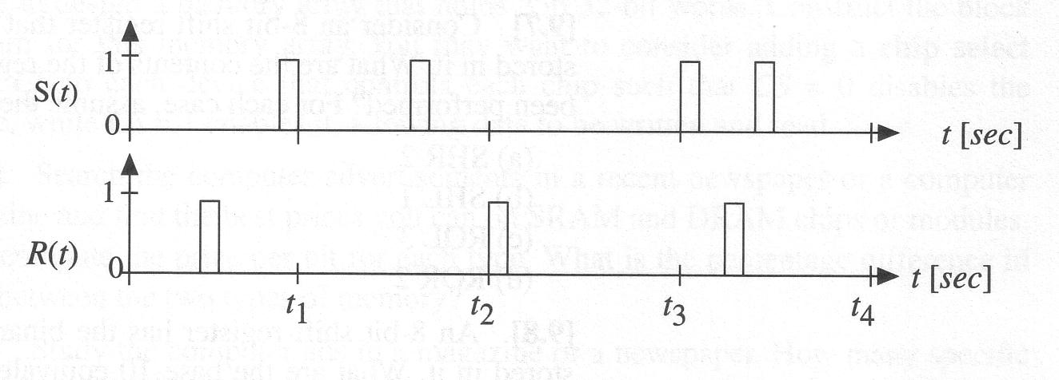

2. The signals shown below are applied to a clocked SR latch. Draw the output waveform. (Ignore all timing delays)

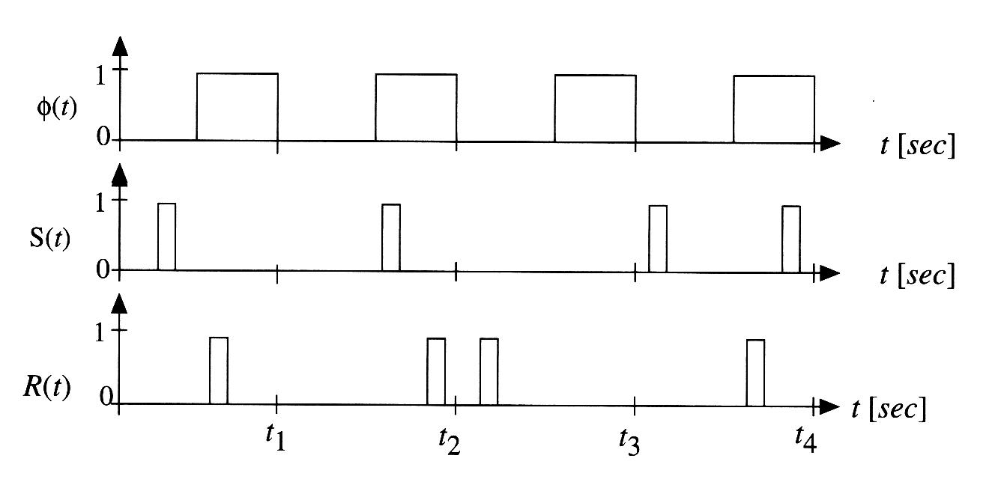
3. The data signal D(t) shown below is applied to the input of a positive edge-triggered DFF. Draw the output Q(t) for the device. (Ignore all timing delays)

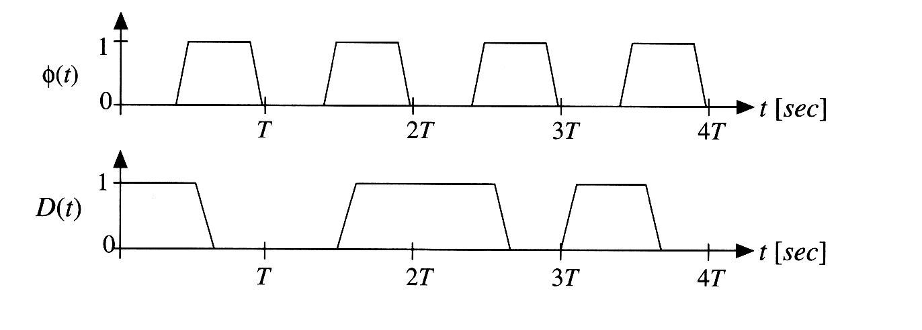

4. Redo the previous problem for the case where D(t) is applied to the input of a negative edge-triggered DFF.

5. Consider the NAND-based SR latch. What are the outputs, 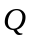and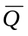, when both S = 0 and R = 0? Why is this the “not used” case?

6. An 8-bit shift register has the binary equivalent of the decimal number 46 stored in it. What are the base-10 equivalent contents of the register after the following operations have been performed? For each case, assume the same initial state given.

(a) SHR 1
(b) SHL 1
(c) SHR 2
(d) ROR 2

7. Consider the 8 X 8 SRAM array. The contents of each row are given by the following list:

Row 0: 0110 0110
Row 1: 1111 0000
Row 2: 0000 1111
Row 3: 1010 1010
Row 4: 0101 0101
Row 5: 0000 1111
Row 6: 0011 1100
Row 7: 1100 0011

What is the decimal value of the output when the following addressees are applied to the row decoder?

(a) 100
(b) 010
(c) 101
(d) 110

8. Consider the 64 X 8b SRAM. This device is to be used as a basic building block for creating a larger memory array with a size of 64 X 16b. Draw a block diagram for the large memory. (Hint: two 64 X 8b SRAMs should be used)

